**COVID-19 IMPACT ON ECONOMY**

JAYDITYA SHUKLA : 22070126109

TEJAS THANGE : 22070126121

VAIBHAV SHARMA : 22070126125

**1. INTRODUCTION**

In today's rapidly changing global economy, understanding the impact of various factors on a country's Gross Domestic Product (GDP) is of paramount importance. This data story aims to delve into the intricacies of how different economic sectors in various countries have been affected by external events. We will explore the dataset that contains information on GDP and employment data for multiple countries and sectors.

**2. PROBLEM STATEMENT**

The world faces numerous challenges that can significantly influence a nation's economy. This dataset seeks to address the following problem statement:

**"How do different economic sectors contribute to a country's GDP and employment, and how have they been affected by external factors, particularly in the context of containment measures and demand shocks?"**

By analyzing the data, we aim to gain insights into the vulnerability of various sectors and countries to such shocks and understand the broader implications for economic stability.

**3. DATASET DESCRIPTION**

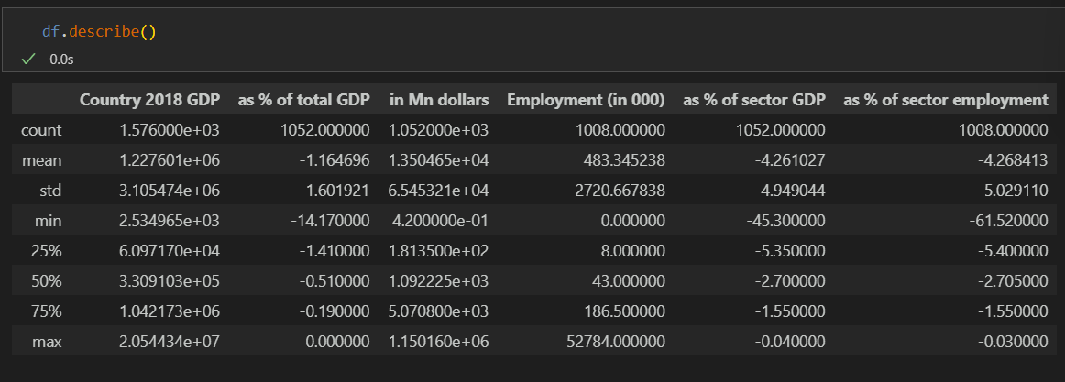

The dataset at our disposal provides comprehensive information for our analysis:

* **Economy**: This column represents the name of the country's economy.
* **ADB Country Code**: A unique code assigned to each economy by the Asian Development Bank.
* **Sector**: Describes the economic sector to which the data pertains.
* **Country 2018 GDP**: The GDP of each country in 2018.
* **Scenario**: Different scenarios representing containment measures and demand shocks.
* **As % of total GDP**: Percentage change in GDP due to the scenario.
* **in $ Mn**: The GDP change in million dollars.
* **Employment (in 000)**: Employment in thousands in the respective sector.
* **As % of sector GDP**: Percentage of sector GDP.
* **As % of sector employment**: Percentage of sector employment.

This dataset is a valuable resource for analyzing the relationship between economic scenarios, GDP, and employment in various sectors.

**4. JUSTIFICATION**

The importance of this data story lies in its potential to inform policymakers, economists, and stakeholders about the resilience and sensitivity of different sectors within an economy. By exploring how scenarios affect GDP and employment, we can identify areas of vulnerability and opportunities for improvement. This analysis can guide decision-makers in developing strategies to mitigate economic shocks and promote stability and growth.

In conclusion, this data story will explore the intricate relationship between economic scenarios, GDP, and employment, offering valuable insights into the economic dynamics of multiple countries and sectors.